You’re a Smart Kid
Name _______________________________
Which smart kid trait describes you best? _________________________________
Smart Kids Traits of __________________________________________
Students | 14
 | 13
 | 12
 | 11
 | 10
 | 9
 | 8
 | 7
 | 6
 | 5
 | 4
 | 3
 | 2
 | 1
 |  | Nature | Art/Picture | People | Body | Self | Music | Logic | Word
 |  | Smart Kid Traits

What other traits are like you? ______________________________________________________________
Smart Kid Traits
Name _____________________________
Nature  - Love being outdoors  - Like plants and animals  - Take care of the Earth  - Collect bugs, leaves, and rocks | Art/Picture  - Love art  - Think in pictures  - Play around with shapes  - Enjoy building things
People  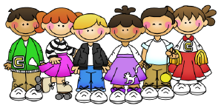  - Love people  - Make friends easily  - Like to work with others  - Care about others | Body  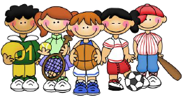  - Love movement  - Are good at sports  - Enjoy acting and dancing  - Like outdoor activities
Self  - Love time to yourself  - Think about feelings  - Feel good about yourself  - Set goals for yourself | Music  - Love music  - Play an instrument  - Sing and tap to music  - Sing and make up songs
Logic  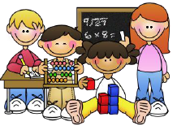  - Love playing with numbers  - Like science experiments  - Like to play strategy games | Word  - Love to read  - Enjoy word games  - Write stories or poetry  - Like to tell stories

