Project Based Learning Grade Level _______
RFF Day – November 7, 2016

Reflection
Work as a team to reflect on your first PBL Unit using the Project Design Rubric (rubric attached). 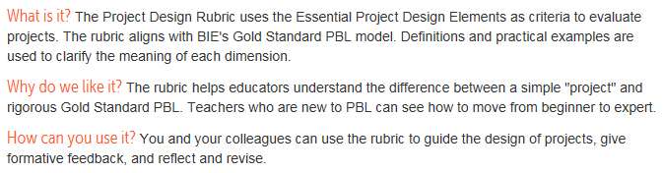
What elements(s) were you most successful?

What elements(s) would you like to improve in your next unit?

What ideas from today’s PD (Voice/Choice & Just-In-Time Direct Instruction) did you already include in your unit? What ideas could you add to the unit in the future?

Are there any materials or supplies you wish you would have had?

